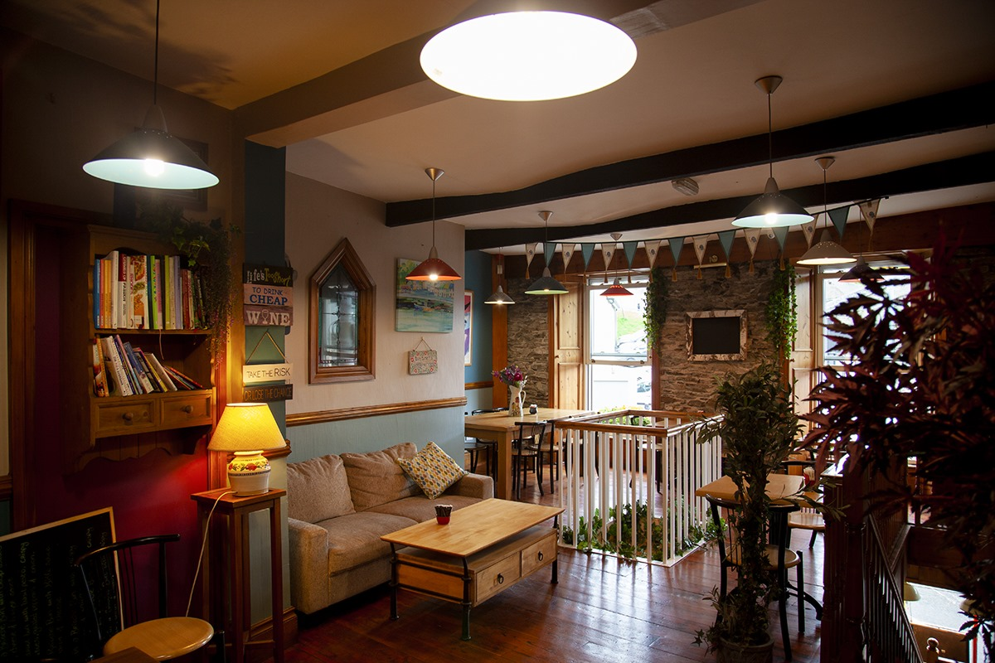
Ann McDonald’s Café/Restaurant
Menu

Homemade Soup of the Day(please ask server) with fresh homemade brown bread(1, 2) €5.75

Traditional Toastie (Wexford honey roast ham, diced red onion, Wexford Cheddar cheese and
vinetomato)(1, 2) €6.00

Classic Toastie (Oven baked chicken, Dubliner red cheddar cheese, vine cherry tomato, and
diced red onion)(1, 2) €6.50

Toasted Hawaiian Special (Wexford honey roast ham, pineapple chunks, Wexford cheddar
cheese on brown bread toasted) €6.95

The Crispy BLT (Pat O’Neills dry cure bacon, vine tomato and mixed leaves with mayo) (2, 4, 10) €6.00

The BIG Triple Decker Club Sandwich (2, 4, 10) €8.95
(Pat O’Neills crispy bacon, oven baked chicken, poached egg, vine tomato, assorted leaves & mayo)

Cajun Wrap (Lettuce, diced red onion, and oven baked chicken in a spicy Cajun sauce)(1, 2, 7, 10) €7.95

Chicken Satay Wrap (Chicken satay, shredded lettuce & diced red onion)(2, 4, 7, 10) €7.95

Louisiana Chicken Wrap €8.75
(Louisiana chicken goujons, Mozzarella Cheese, Garlic Mayonnaise,
Iceberg lettuce in a toasted wrap) (1, 2, 4, 7, 10)

Chicken Stuffing Panini €7.95
(Oven baked chicken with homemade stuffing and mozzarella cheese) (1, 2, 4, 10)

Panini of the day served with hand-cut chips (Ask your server for details) €11.95

Side orders

Fresh hand cut chips €3.90

Desserts (Please see dessert fridge for selection) €5.50

Allergens: 1. Milk, 2. Cereals, 3. Crustaceans, 4. Eggs, 5. Fish, 6. Peanuts, 7. Soybeans, 8. Nuts, 9. Celery, 10. Mustard, 11. Sesame Seeds, 12. Sulphur dioxide & Sulphites, 13. Lupins, 14. Molluscs

Ann McDonald’s Café/Restaurant
Menu

Vegetarian Options

Vegetarian Panini (1, 2) €8.50
(Roasted Mediterranean vegetables, goats’ cheese, sun blushed tomatoes & pesto)

Vegetarian Quiche (served with crispy garden salads) (1,2,4) €10.95

Vegetable Curry with rice or home-cut chips (for half and half add 1.00 extra) (9, 10)
(Mediterranean vegetables in a creamy curry sauce) €12.50

House Vegan Wrap
(Wild Rocket leaves, Crunchy Colourful Vegetables, Beetroot and Carrot Salad, with sundried
Tomatoes and Pesto Dressing ) €8.50

Main Courses

Mini Grill (2 craft butcher sausages, 2 O’Neill’s bacon, egg, and home-cut chips) (2, 4, 12) €10.95

Cold Meat Platter (assorted homecooked meats with a selection of homemade salads) €13.50

Caesar Salad (Irish chicken on a bed of leaves with cucumber, cherry tomato, boiled egg, croutons
Topped with parmesan and creamy dressing)(1, 4) €11.95

Baked Italian Lasagne €12.95
Leanest Irish minced beef in a rich tomato & garlic sauce, between layers of pasta, topped with creamy cheese sauce, with salad garnish, home-cut chips or assorted salads (1, 2,)

Savoury Omelette (Served with side salad and home-cut chips) (1, 4) €11.95

Southern Fried Goujons with home-cut chips(2, 12) €12.95

Deep Fried Scampi with home-cut chips(2, 3) €13.50

Chicken Curry with rice or home-cut chips (for half and half 1.00 extra) (9, 10) €12.50

Allergens: 1. Milk, 2. Cereals, 3. Crustaceans, 4. Eggs, 5. Fish, 6. Peanuts, 7. Soybeans, 8. Nuts, 9. Celery, 10. Mustard, 11. Sesame Seeds, 12. Sulphur dioxide & Sulphites, 13. Lupins, 14. Molluscs

