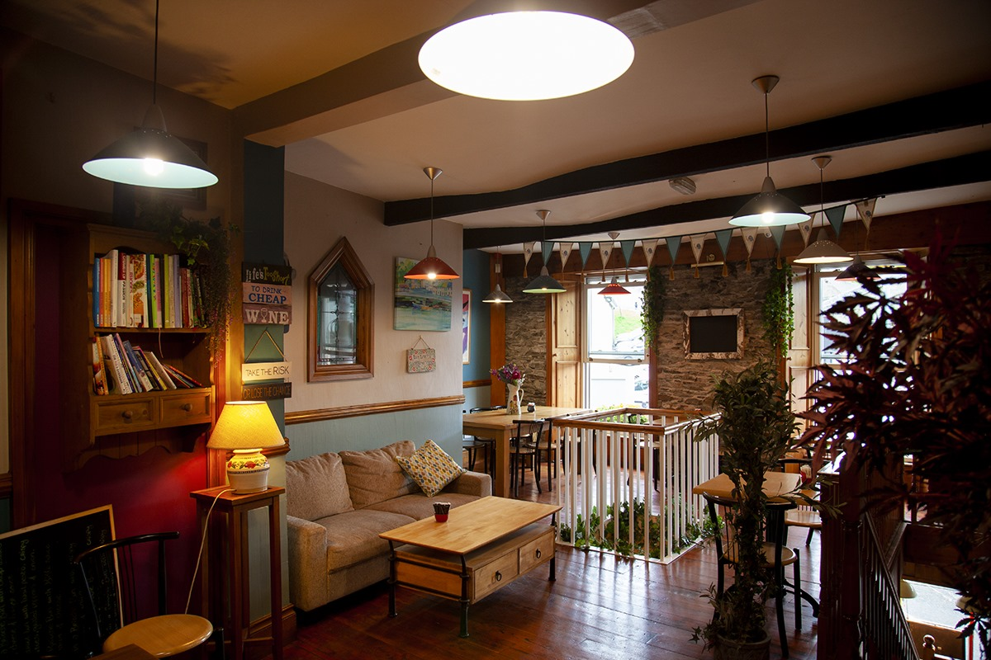
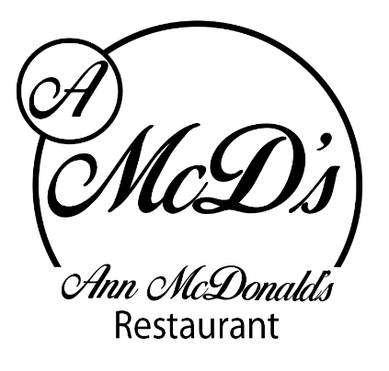
Ann McDonald’s Café/Restaurant
Breakfast Menu

Porridge with berry compote, Greek yogurt and raw honey 1,2 €8.00

Traditional Full Farmhouse Breakfast: 2 craft butcher sausages, 2 O’Neill’s bacon, 2 craft puddings, local free-range egg, mushrooms, beans & hashbrown, toast, tea or coffee 1, 4, €11.00

Traditional Farmhouse small Breakfast: 1 craft butcher sausage, 1 O’Neill’s bacon, 1 craft pudding, local free-range egg, 1 craft pudding, beans & hashbrown, toast, tea or coffee 1, 4 €9.00
Toasted sausage sandwich 1, €5.00

Toasted Bacon Sandwich: made using O’neills Bacon 1 €5.95

Scrambled Free-range Eggs with O’Neill’s dry cure Bacon 1, 4 €9.50

Slimmer’s Choice: Poached Eggs, grilled tomato, mushrooms and 2 grilled O’Neill’s bacon
Homemade brown bread, tea or coffee 1, 4 €11.00

Vegetarian Breakfast: 2 local free-range eggs, baked beans, mushrooms, grilled tomato and sauté potatoes, toast, tea or coffee 1, 4 €11.00

Smashed Avocado, crispy bacon and local free-range poached eggs on sourdough toast 4, 1 €11.00

Pancake stack with crispy bacon and maple Syrup 1, 2, 4 €10.50

Pancake stack with fruit compote and Greek yogurt 1, 2, 4 €9.95

Ann’s freshly baked scone with Wexford home preserve and fresh cream 1, 2, 4 €3.00

Freshly Squeezed Orange Juice €4.00

Tea €2.50 Americano €3.00 Cappuccino €3.80
Speciality Tea €2.80 Mocha €3.95 Hot Chocolate €3.95
Iced Coffee €4.30 Double Espresso €2.80 Latte €3.80

Food Allergens:
1; Cereals containing gluten 2: Milk 3: Crustaceans 4: Eggs 5: Fish 6: Peanuts 7: Soybean 8: Nuts 9: Celery 10: Mustard 11: Sesame Seeds
12: Sulphur dioxide and Sulphites 13: Lupins 14: Molluscs

